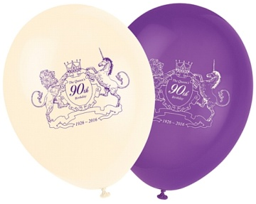
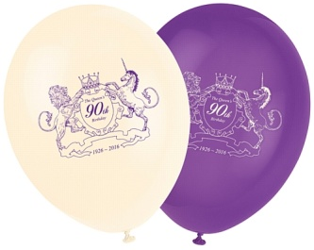
Queens 90th Birthday Celebrations

The community will be celebrating the Queens 90th Birthday on the afternoon of the 12th June at 3.30pm

Commemorative Coin will be presented to all children under 16 years of age living in the Parishes of
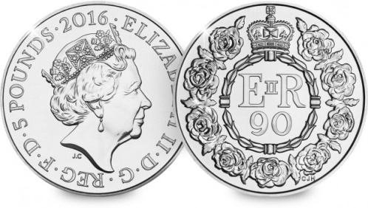
- Llanbadarn - Fynydd
- Llaithddu
- Llananno

Hog Roast will be provided by the community council at The New Inn

